**Pizza Sales Dashboard**

**Overview**

This project provides interactive and in-depth insights into pizza sales performance, including quarterly, monthly, daily and hourly trends, sales by pizza category and size, and identifying top-selling pizzas based on revenue, quantity, and total orders.

This analysis provides data-driven view of pizza sales performance, designed to help the company understand key trends, customer behaviour, enable better data-driven business decisions for future expansion and boost revenues. The dataset includes order details in 2015, with information on the date and time orders placed, and the quantity ordered for each pizza type and size.

**Project Goal**

* Analyze hourly, daily, weekly, and monthly sales trends throughout 2015.
* Identify peak sales periods and any noticeable patterns or seasonality.
* Rank pizza categories and individual pizzas by quantity sold and revenue generated.
* Identify the top 5 and bottom 5 performing pizzas in terms of both quantity and revenue.
* Analyze the relationship between pizza size and sales performance within each category.
* Determine the most popular pizza sizes across all categories and for individual pizzas.
* Analyze the frequency of single-item orders versus multi-item orders.
* Rank ingredients by frequency of use across all pizzas.
* Investigate any correlation between specific ingredients and sales performance and quantity sold.
* Investigate any correlation between pizza prices and sales volume for each category.
* Determine the average number of orders placed by each customer.
* Analyze the average time interval between orders for a single customer.

**Data Transformation and Modelling**

The data from the dataset was organised into 3 separate tables to facilitate analysis:

* **Ingredients**: Contains the ingredient ID, ingredient names and pizza ID.
* **Pizza**: Contains the category name, ingredient ID, ingredient names, pizza names, pizza ID and sizes.
* **Sales**: Contains the date, ingredient ID, order ID, pizza ID, price, quantity and time.

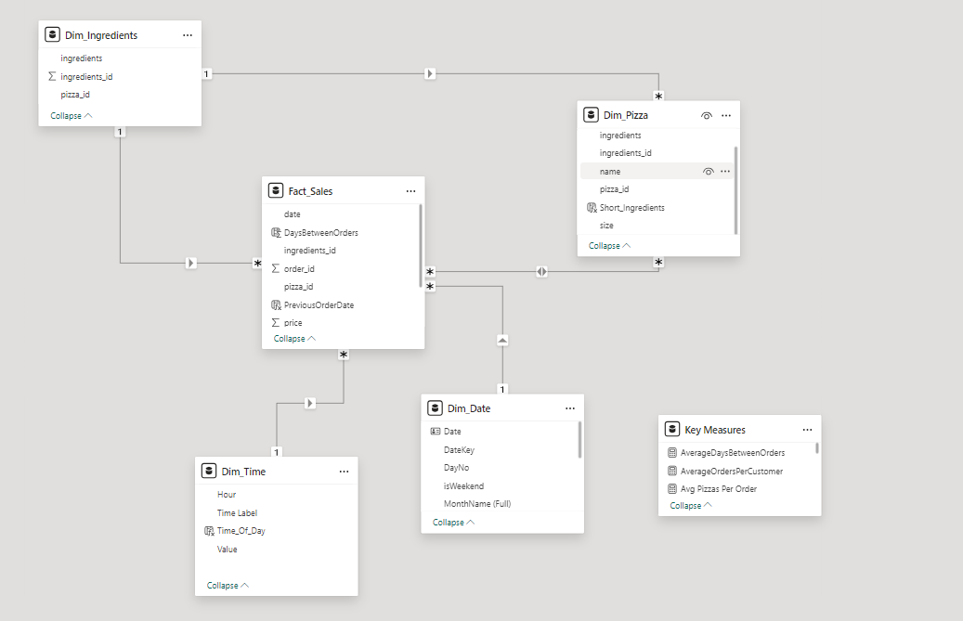

**Dashboard Overview**

The Pizza Sales Report provide a user-friendly interface and offer the following views:

**Overview and Sales Trend Dashboard**

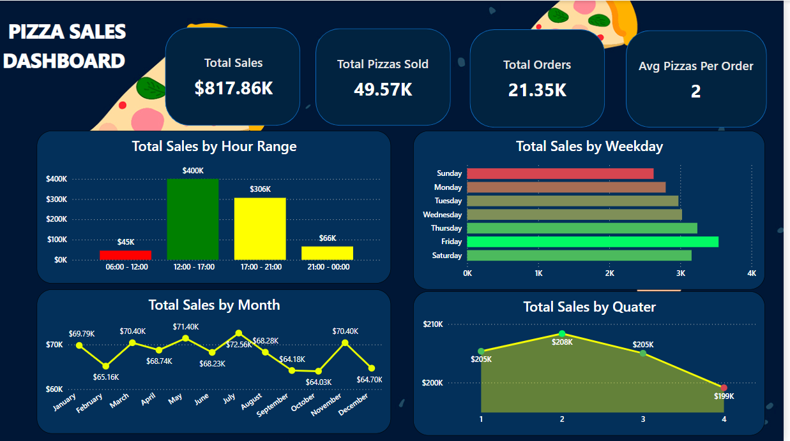

* The first bar chart shows sales revenue across different hourly ranges, with the highest sales occurring between 12:00 - 17:00 ($400K) and the lowest between 06:00 - 12:00 ($45K).
* The horizontal bar chart illustrates sales performance by day of the week, with Friday recording the highest sales at $136.07K, followed by Thursday and Saturday, while Sunday has the lowest sales volume at $99.20K.
* The line chart tracks total monthly sales, peaking in July at $72.56K and dipping to its lowest in February, September, October, and December, indicating seasonal trends in pizza sales.
* The area chart displays total sales by quarter, highlighting quarter 2 as the highest performing quarter at $208.4K, while quarter 4 shows the lowest sales at $199.1K.

**The Total Order by Hour Tooltip**

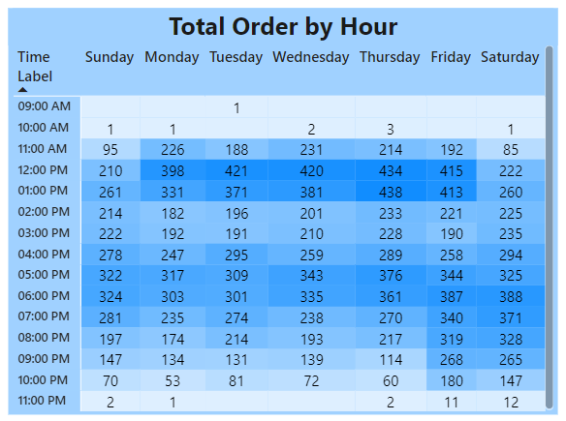

* The Total Order by Hour Tooltip displays the total number of pizza orders for each hour of the day across the week, allowing for quick identification of peak and low ordering times through a colour gradient.
* The highest number of orders occurred at 12:00 PM – 01:00 PM from Monday to Friday and 06:00 PM – 07:00 PM on Saturday and Sunday.

**Product Performance Dashboard**

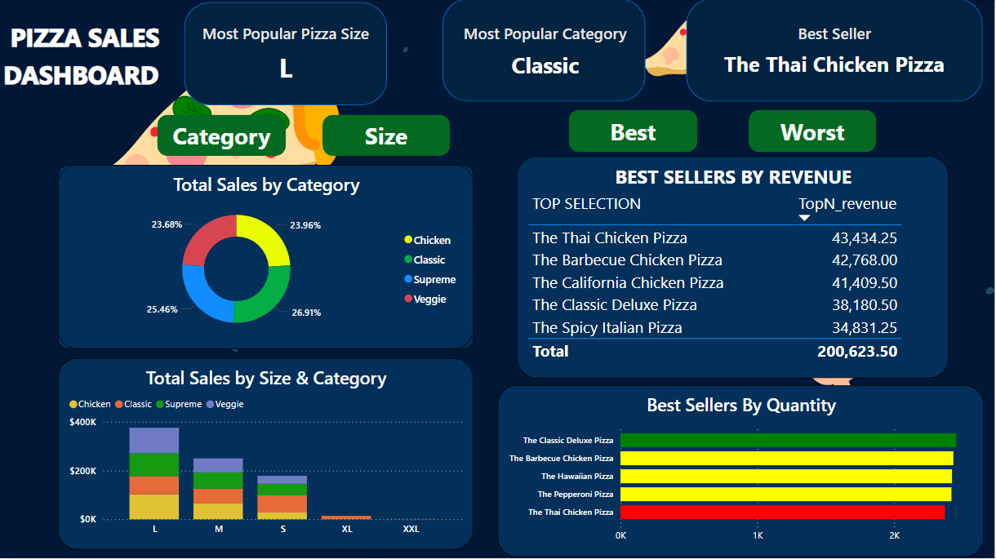

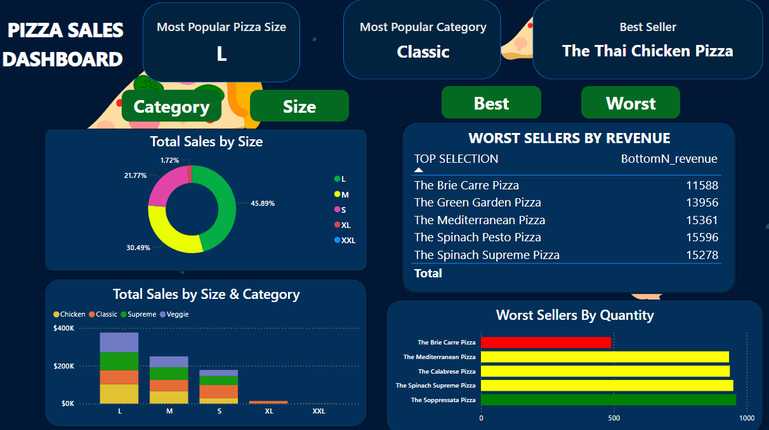

* The pie chart shows sales proportions by pizza category. The Classic category is the most popular in terms of orders and generates the highest revenue.
* The stacked bar chart illustrates sales breakdowns by size (L, M, S, XL, XXL) across the four categories (Chicken, Classic, Supreme, Veggie). The large size of pizza was the most preferred by customers.
* The Thai Chicken pizza contributed the most to the increase in total revenue. Additionally, the Classic Deluxe was the best seller and the most frequently ordered. In contrast, the Brie Carre was the least ordered and sold pizza.

**Product Dashboard**

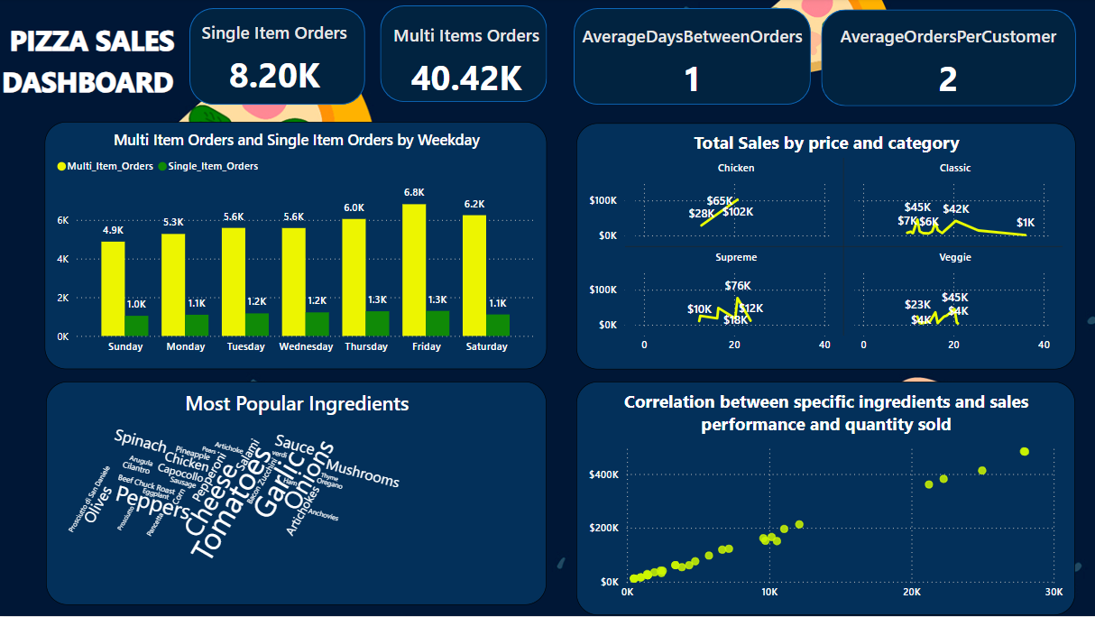

* The bar chart showing that most orders are multi-item orders, peaking on Friday with 6.8K total orders. The single-item orders are less popular, stay stable at around 1K – 1.3K orders every day.
* Chicken: Sales rise from $28K to $102K within the first 20 price points, with a sharp upward trend.
* Classic: Sales fluctuate between $6K and $45K within the first 10 price points, and then gradually drop to $1K by the 40th price point.
* Supreme: Sales spike to $76K around the 20th price point, but drop back to $12K by the 30th price point, showing high volatility.
* Veggie: Sales peak at $45K near the 20th price point, with frequent sharp dips and rises between $4K and $45K throughout the range.
* The word cloud includes larger text size indicating higher usage of "Cheese," "Tomato," and "Garlic" being the most popular ingredients.
* The scatter plot displaying a positive correlation between specific ingredient sales and overall sales revenue, with higher sales corresponding to more frequently used ingredients.

**Suggestions for the pizza company**

* Capitalize on Peak Hours: Since the highest sales occur between 12:00 PM and 5:00 PM, consider offering promotions or special deals during this time to boost revenue even further.
* Target Weekend Sales: With Fridays and Saturdays showing the highest order volumes, the company could introduce exclusive weekend offers or bundle deals to increase sales and customer engagement.
* Boost Sales During Off-Peak Hours: The morning hours (6:00 AM - 12:00 PM) and late-night periods (10:00 PM onward) show the lowest sales. Introducing breakfast items or late-night promotions could help drive more sales during these periods.
* Seasonal Promotions: Sales peak in June and October, suggesting potential seasonality. The company should plan marketing campaigns around these times to maximize revenue. Additionally, promotions during lower-sales months like January could help smooth out the seasonal fluctuations
* Optimize for Quarterly Performance: With Q2 performing the strongest, the company could align its major marketing and promotional efforts during these quarters to maximize returns while maintaining steady promotions in other quarters.
* Product Diversification: If specific pizza types or sizes perform better in certain periods or time frames, diversifying offerings based on customer preferences (e.g., family-sized pizzas for weekends) could further increase sales.